CLIENT DESIGN REVIEW: DITSHUPO ENVIRONMENTAL ENGINEERING

ANALYSIS DONE BY: NKOSINATHI MDALA (43235735)
PROJECT ID: CMPG325-2026-070
CLIENT ID: CLI-070
INDUSTRY: ENGINEERING

CLIENT INFORMATION AND PROBLEMS

ABOUT DITSHUPO ENVIRONMENTAL ENGINEERING
Ditshupo Environmental Engineering is a substantial environmental engineering consultancy based in Kimberley, Northern Cape, serving mining, municipal, and industrial clients across the Northern Cape region. They handle mine rehabilitation, large-scale water quality monitoring, environmental impact assessments (EIA), soil and groundwater remediation, and ongoing compliance monitoring contracts.
They hire around 420 members of staff, spread across a main office/lab campus and a couple of satellite site offices near active mining operations. Their staff includes:
- Around 150 field engineers and technicians, primarily tasked with site sampling, monitoring, and remote environmental data collection across multiple mine sites. Many of them carry laptops or tablets and connect via field VPN.
- Around 60 members of laboratory staff responsible for running a full analytical lab with numerous networked instruments such as water quality analysers, spectrometers, gas chromatographs and automated samplers
- A dedicated GIS/CAD team that produce site maps, 3D terrain models and remediation designs. They have heavy workstations and require large file transfers. They number around 40.
- Environmental scientists and compliance specialists that do EIA drafting, regulatory liaison and data analysis. They number around 50.
- Project management and administration staff that handle client liaison, scheduling, invoicing, Human Relations and finance. They number around 80.
- Reception, facilities, and support staff of around 40 members in total
- Only one IT support person who works part-time

Ditshupo’s current network situation
Ditshupo Environmental Engineering has an IP addressing block of 172.30.44.0/23. Everything, like guest Wi-Fi, lab instruments, workstations, GIS rigs, and so on, all draw their IP addresses from the same pool.
Everything currently sits on a single flat, unsegmented network:
- Around 300+ office/admin and scientist workstations
- A large lab area with dozens of networked instruments and sensors reporting into LIMS (Lab Information Management System)
- Around 40 GIS/CAD workstations doing large geospatial file transfers
- Server room (LIMS database, GIS file store, backups, domain services)
- Guest/visitor Wi-Fi, which are still not separated from staff network
- Around 150 field staff connecting via VPN from site laptops and tablets across multiple mine locations
- Two satellite site offices, each with their own small local device footprint, currently bridged back to the main network with no real separation

DITSHUPO’S CHALLENGES
There are currently several problems with their network’s design, including:
- Having no segmentation, despite the scale of their operations: A compromised guest or field device can potentially reach lab instrumentation, GIS file stores, or admin systems, putting their system data at risk
- Having one part-time IT support person for the entire organization: having over 400 staff and hundreds of devices effectively resting on infrastructure maintained by one contractor who isn't on-site full time.
- There is no networking expertise aside from the one part-time IT support person, so anything implemented must be well documented, self-explanatory and of low maintenance.
- Compliance from mining companies now requires demonstrable network segmentation and access controls before sharing compliance data with Ditshupo.

DITSHUPO’S GOALS AT PRESENT
- Segment traffic types, such as admin, lab, GIS/CAD, guest, field VPN and satellite sites so a breach in one area doesn't expose the others
- Make efficient, close-to-full use of the IP addressing block given their real device count, without over-engineering
- Build something so simple and well-documented that a single part-time person can maintain it with minimal ongoing effort
- Provide credible evidence of network security/segmentation to mining clients who require it for contract renewal

ANALYSIS OF DITSHUPO’S REQUIREMENTS

USER NEEDS FOR EACH DEPARTMENT
- Project management and administration: Reliable desktop access, shared drives, VoIP/phones, internet browsing
- Field Engineers and Technicians: VPN access from site laptops and tablets, intermittent/mobile connectivity, access to LIMS and file shares remotely
- Laboratory Staff: Access to networked lab instruments, LIMS write access and sample tracking
- GIS/CAD Team: High bandwidth for large geospatial file transfers, powerful local storage/caching, access to GIS file server
- Environmental scientists and compliance specialists: Document drafting, regulatory data access, with some crossover with GIS and admin systems
For the guest/visitor network, basic internet-only access for client visitors, auditors, contractors should suffice.

APPLICATIONS REQUIRED TO SERVICE
Ditshupo would require connectivity to the following applications and services:
- A Laboratory Information Management System for the lab staff
- GIS platform (ArcGIS) + file server, primarily used by the GIS/CAD team
- EIA/document management used by the environmental scientists and compliance specialists
- Microsoft 365 for project management and administration staff
- VPN concentrator for the field staff on the ground
- A Backup server
- Lab instrumentation network for the lab department
- Guest Wi-Fi for the presence of guests, such as auditors, to our network

DITSHUPO’S SECURITY NEEDS
As mentioned before, the company network’s lack of segmentation must be addressed, as a lot of information is at risk of being lost. Their biggest gaps are the isolation of the guest Wi-Fi from the network used by the staff, and the isolation of lab instruments from the rest of the network. The field VPN needs strong authentication to mitigate the damage caused by device loss or theft.

DITSHUPO’S PROPOSED BUDGET FOR THE TASK AT HAND
Ditshupo’s proposed budget stands at R90 000 to R120 000. This budget favors simple, low maintenance solutions given the current state of the IT team at present.

DITSHUPO’S GROWTH
Currently, Ditshupo projects that the field staff and satellite locations are the avenues that could record the highest growth. It is therefore worth noting that the address space must be reserved to accommodate this growth.

LOGICAL TOPOLOGY
Based on Ditshupo’s network structure at present – it being a flat, unsegmented network – we need to choose a network topology that can cover the company’s needs, based on the following framework:
- The scale of the company’s network, both for the present and future
- The redundancy and fault tolerance needs of the company
- The cost of implementing said network within the budget set out by the company
- The internet traffic patterns of the company
- The manageability of the network since we have only one part-time IT support person to maintain the network

Scale
Ditshupo currently has around 420 members of staff, spread out across 6 departments. The number of staff, along with the associated devices of the departments, sit well within the range of a switched hierarchical star topology.
Growth is uneven within the company, as field staff and satellite site offices are the fastest growing parts of the company. These parts are tied to new mining contracts, while administrative, GIS/CAD, and lab departments grow slowly.

Redundancy/fault tolerance
Given the absence of a dedicated, full-time network engineer, Ditshupo cannot realistically operate or troubleshoot a fully redundant mesh design. A single point of failure at the core switch is an acceptable, managed risk at this scale, provided basic protections for the network are in place. The basic protections could include an Uninterruptible Power Supply to protect the core switch.

Cost
Given the budget given of between R90 000 and R120 000, the cost of cabling requirements and switch ports must be considered. A bus network topology would not be suitable for this purpose, as despite it having the lowest cost among known topologies, there are simply too many devices that would need to share a single cable, and it would not be easily scalable.
The ring topology would give us predictable performance and low cost, but the risk of one node failure affecting every other node in the network is simply too risky to even consider.
The mesh topology would also need to be ruled out, simply because of how expensive it would be to install and maintain the entire network. There would simply be no money to implement a proper, redundant topology with such a modest budget.
The star topology would be the best choice then, due to the cost of the cabling (as it uses twisted pair cables mostly, although fiber optic cables can be considered at a larger cost). However, since we must cover the main office and two satellite site offices on the ground, a simple star topology would not be cost effective.
This would leave us with the extended star topology, which allows us to use more switches and connect them to a single core switch, increasing the coverage of the network to the two satellites without increasing the cost of the whole network by much.

Traffic Patterns
Ditshupo's traffic is predominantly north to south: department workstations, field devices, and lab instruments communicate primarily with central servers like the LIMS, GIS file store and backup, not with each other. This client-to-server pattern aligns naturally with an extended star design, in which all traffic flows toward a central switching point. GIS/CAD file transfers are bandwidth-heavy but remain client-to-server, affecting link/uplink sizing rather than the topology choice itself.

Manageability
Manageability is a very important factor to consider, as Ditshupo only hires one part-time IT support person. Thus, the documentation of the network must be simple to design and understand. Troubleshooting and maintenance must be simple enough to implement by the IT person without ongoing specialist intervention.
Thus, the Extended star topology is the good choice, on account of its faults being easy to isolate to a single device, cable, or switch port. VLAN segmentation is also native to how star topologies operate and serve the additional purpose of improving Ditshupo’s security.
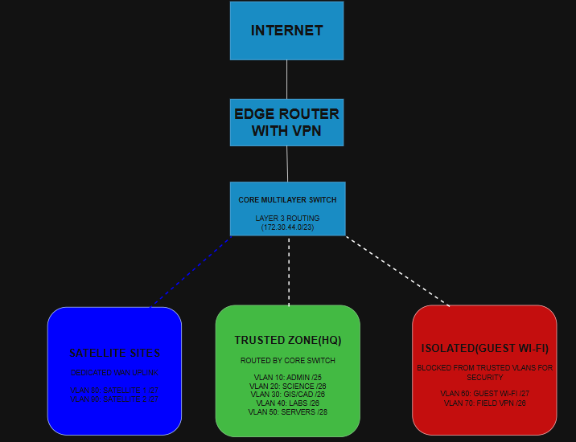
Figure 1: Logical topology of the network structure for Ditshupo

A word on scalability and future growth
The Extended Star topology is not infinitely scalable, as growth is capped by the central switch's port capacity, the cabling plant, and the organization's management capacity.
However, the standard response to this limitation is not to abandon the star topology, but to extend it. As Ditshupo grows, particularly through additional field staff or new satellite sites, the design scales by:
- Cascading additional access switches via high-speed uplinks as port counts are exhausted at existing locations
- Formalizing the hierarchy into a three-tier model (access, distribution, core) if the organization scales substantially (e.g., many more sites or a large increase in headcount)
- Alternatively, adopting a collapsed core approach (distribution switches performing core functions) if growth remains moderate — avoiding the cost of a dedicated core layer until it is justified
This means the topology decision made today does not need to be revisited from scratch as the company grows; it is extended incrementally, in line with actual demand, which suits both the budget and the single-person IT team's capacity to manage change gradually rather than through disruptive redesigns.

PHYSICAL TOPOLOGY

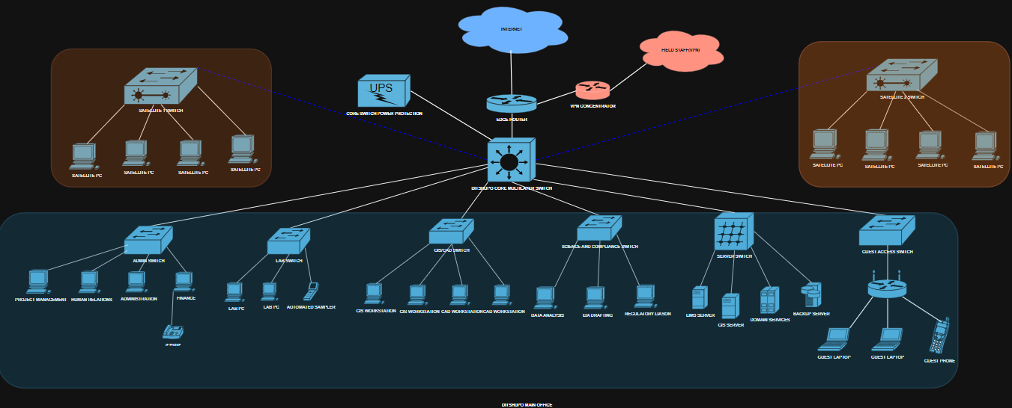
Figure 2: Ditshupo physical network topology, main office and satellite sites

Overview
The physical topology mirrors the extended star design chosen above. All main-office traffic converges on a single core multilayer switch, which is the only Layer 3 device on the network and therefore the point at which every VLAN in the IP addressing plan is routed. The core switch has three categories of physical connections: an uplink to the Edge Router (and, through it, the Internet and the VPN concentrator serving field staff), downlinks to six access-layer switches serving the departments and services at the main office, and two dedicated uplinks to the switches at the satellite site offices.

Main Office Access Layer
The main office houses the core switch, the edge router, the VPN concentrator and the UPS that protects the core switch. Six access switches are cabled back to the core switch over structured copper (or fibre where a link is expected to carry heavy traffic), one per functional area identified in the requirements analysis:
- Administration Switch: Project Management, Human Relations, Administration and Finance workstations, plus the office IP phone system
- Lab Switch: lab workstations and the automated sampler and other networked lab instruments feeding the LIMS
- GIS/CAD Switch: GIS and CAD workstations performing large geospatial file transfers
- Science and Compliance Switch: data analysis, EIA drafting and regulatory liaison workstations
- Server Switch: LIMS server, GIS file server, domain services and the backup server
- Guest Access Switch: the guest wireless access point and any wired guest drops, serving visitor laptops and phones

Because the GIS/CAD team regularly moves large geospatial files and the server switch carries LIMS, GIS file store and backup traffic for the whole site, those two uplinks are the best candidates for a fibre or higher-speed copper (Cat6a) run back to the core switch even though the rest of the access layer can use standard Cat6 twisted pair; this keeps the extra cost limited to the two links that actually need it, in line with the budget allocated to us.

Satellite Site Offices
Each satellite site office near the mine operations has its own small switch (Satellite 1 Switch and Satellite 2 Switch) serving a handful of local PCs. Rather than being bridged flat into the main network as they are today, each satellite switch connects back to the Ditshupo Core Multilayer Switch over a single dedicated point-to-point uplink (a leased line, fibre run or licensed wireless bridge, depending on distance and what is available at each mine site). This dedicated link is kept distinct from the field VPN path so that satellite-office traffic can be placed on its own VLAN and does not depend on the public Internet or the VPN concentrator to reach head office.

Field Staff Connectivity
Field engineers and technicians are not physically cabled into any Ditshupo switch. Their laptops and tablets reach the network over the public Internet, terminating on the VPN concentrator that sits alongside the edge router at the main office. The concentrator is the only physical device field devices touch before reaching the core switch, which keeps the field-access path simple to document and to troubleshoot for a single part-time IT resource.

Redundancy and Power Protection
Consistent with the redundancy analysis above, the design accepts the core switch as a single point of failure rather than building a redundant core, since a dual-core or meshed design would be too costly and too complex for one part-time administrator to maintain. The only redundancy measure in the physical build is a UPS dedicated to the core switch, which protects the single most critical device on the network from short power interruptions and gives the IT contractor time to respond to a longer outage.

IP ADDRESSING PLAN

Design Approach
Ditshupo's entire address space is the single block 172.30.44.0/23 (172.30.44.0 – 172.30.45.255), 512 addresses in total. The plan below subnets that block with Variable Length Subnet Masking into one Virtual LAN per physical/functional switch identified in the physical topology, so that the segmentation the client needs for its own security goals and for mining-client compliance lines up one-to-one with the switches already on the diagram. Subnet sizes are matched to the department headcounts and device counts given in the requirements analysis rather than handed out as equal blocks, which is what lets the plan use almost the whole /23 (492 of 512 addresses, roughly 96%, fall inside a usable host range) without allocating more space than any segment actually needs.
- One VLAN per security/functional zone, matching the access switches already in the physical design, so segmentation, documentation and troubleshooting stay aligned to a single, familiar diagram
- Subnets sized with VLSM against real headcounts and device counts
- The field VPN pool is sized for realistic concurrent sessions rather than the full 150-strong field workforce, since field staff are rarely connected at once
- The two satellite sites are each given more headroom than their current handful of PCs need, since satellite growth is the other area, the client has called out explicitly
- Every VLAN is documented on a single table with its gateway, mask and usable range so the part-time IT contractor can administer it without further networking expertise

VLAN and Subnet Allocation
The Ditshupo Core Multilayer Switch is the sole Layer 3 device and hosts the Switched Virtual Interface for every VLAN below; every subnet's gateway is its first usable address. Guest Wi-Fi and the field VPN pool are additionally isolated from the internal VLANs with access-control lists on the core switch, since those are the two segments the security review flags as needing the strongest separation.

VLAN | Segment | Network (CIDR) | Mask | Usable Range | Gateway | Usable Hosts | Current Devices (estimate)
10 | Admin, PM, HR & Finance (HQ) | 172.30.44.0/25 | 255.255.255.128 | .1 – .126 | 172.30.44.1 | 126 | 120
70 | Field VPN Pool | 172.30.44.128/26 | 255.255.255.192 | .129 – .190 | 172.30.44.129 | 62 | 60 concurrent (of 150 field staff)
40 | Laboratory (PCs & instruments) | 172.30.44.192/26 | 255.255.255.192 | .193 – .254 | 172.30.44.193 | 62 | 80
20 | Environmental Scientists & Compliance | 172.30.45.0/26 | 255.255.255.192 | .1 – .62 | 172.30.45.1 | 62 | 50
30 | GIS/CAD | 172.30.45.64/26 | 255.255.255.192 | .65 – .126 | 172.30.45.65 | 62 | 40
60 | Guest Wi-Fi | 172.30.45.128/27 | 255.255.255.224 | .129 – .158 | 172.30.45.129 | 30 | 15–20 visitor devices
80 | Satellite Site 1 | 172.30.45.160/27 | 255.255.255.224 | .161 – .190 | 172.30.45.161 | 30 | 4, room to grow
90 | Satellite Site 2 | 172.30.45.192/27 | 255.255.255.224 | .193 – .222 | 172.30.45.193 | 30 | 4, room to grow
50 | Servers (LIMS, GIS store, backup, domain services) | 172.30.45.224/28 | 255.255.255.240 | .225 – .238 | 172.30.45.225 | 14 | 6–8
99 | Network Management (switches, router, VPN concentrator) | 172.30.45.240/28 | 255.255.255.240 | .241 – .254 | 172.30.45.241 | 14 | 10

Notes on Growth and Maintenance
- The two /24 halves of the block split cleanly along physical lines: 172.30.44.0/24 covers Admin, the field VPN pool and the Lab, while 172.30.45.0/24 covers Scientists, GIS/CAD, Guest, both satellites, Servers and network management. A contractor can find any device's VLAN from the diagram alone without memorising the whole table
- Reserve a handful of static addresses at the top of the Server and Management ranges for anything added later (e.g. an additional server or a second AP), and let DHCP serve the remainder of every other VLAN
- If concurrent field VPN sessions regularly approach 60, or a satellite site's headcount approaches 30, that is the signal to plan for supplemental address space rather than renumbering, since almost no spare capacity is left elsewhere in the /23 to reclaim
- Keeping one VLAN per access switch means a future access switch added to any department only needs a trunk back to the core switch carrying that department's existing VLAN, so no new subnet must be designed for routine growth

REFERENCE LIST
CISA (Cybersecurity and Infrastructure Security Agency). 2022. Layering network security through segmentation. [Online]. Available: https://www.cisa.gov/sites/default/files/publications/layering-network-security-segmentation_infographic_508_0.pdf [Accessed 15 August 2026].
CISCO. 2026. IP addressing configuration guide. [Online]. Available: https://www.cisco.com/c/en/us/td/docs/routers/ios-xe/ip-addressing/ip-addressing.html [Accessed 20 August 2026].
CLOUDMYLAB. n.d. Star topology: architecture, use cases & when to avoid it. [Online]. Available: https://blog.cloudmylab.com/star-network-topology [Accessed 18 August 2026].
CMU SEI (Software Engineering Institute). n.d. Network segmentation: concepts and practices. [Online]. Available: https://www.sei.cmu.edu/blog/network-segmentation-concepts-and-practices/ [Accessed 17 August 2026].
COMPLIANCE MANAGER GRC. n.d. PoPIA – Condition 7 security safeguards standards. [Online]. Available: https://www.compliancemanagergrc.com/standards/popia/ [Accessed 15 August 2026].
DOCUSNAP. n.d. Network topologies: all types, pros & cons compared. [Online]. Available: https://www.docusnap.com/en/it-documentation/network-topology-why-choosing-the-right-structure-is-crucial [Accessed 16 August 2026].
ITU ONLINE. n.d. Topologies in network design: definitions and best practices. [Online]. Available: https://www.ituonline.com/blogs/topologies-in-network-design-definitions-and-best-practices/ [Accessed 18 August 2026].
TANENBAUM, A.S. & WETHERALL, D.J. 2011. Computer networks. 5th ed. Boston: Pearson.
TUTORCHASE. n.d. Choosing and justifying topologies. [Online]. Available: https://www.tutorchase.com/notes/cie-a-level/computer-science/2-3-2-choosing-and-justifying-topologies [Accessed 19 August 2026].

